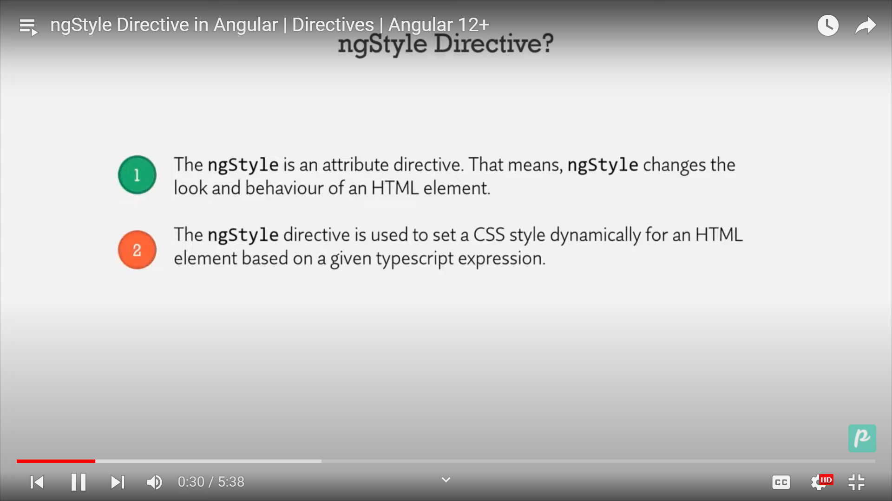

<span [ngStyle]="{ color: p.details === 'availabe' ? 'Green' : 'Red' }"

    >Product is {{ p.details }}</span

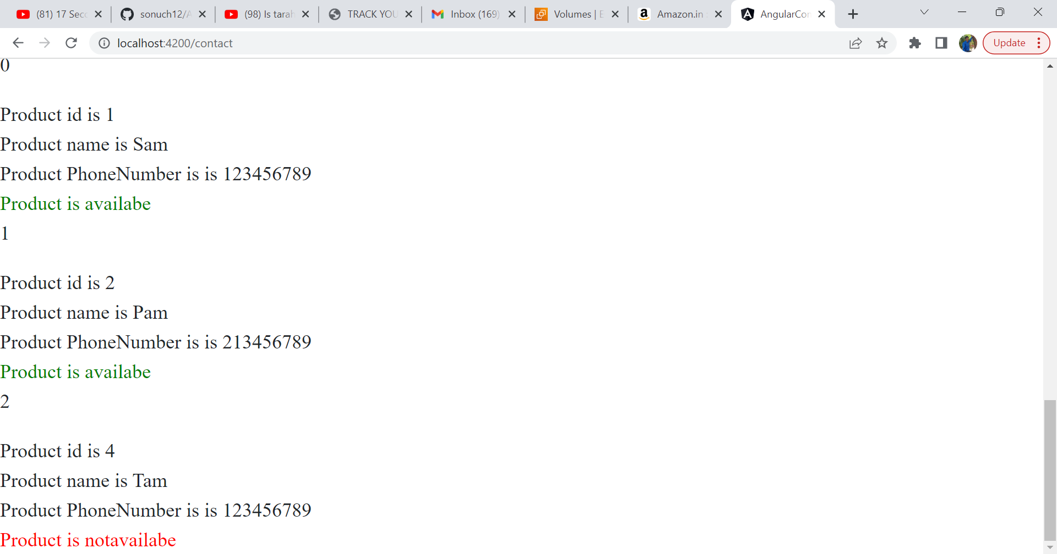

<div \*ngFor="let item of [1, 4, 8, 9]">

  <p>Number of items is {{ item }}</p>

</div>

<div

  \*ngFor="let p of pro; let i = index"

  [ngStyle]="{ backgroundColor: p.details === 'availabe' ? 'Green' : 'Red' }"

>

  <p>{{ i }}</p>

  <span>Product id is {{ p.id }}</span>

  <br />

  <span>Product name is {{ p.name }}</span>

  <br />

  <span>Product PhoneNumber is is {{ p.phNumber }}</span>

  <br />

  <span [ngStyle]="{ color: p.details === 'availabe' ? 'Green' : 'Red' }"

    >Product is {{ p.details }}</span

  >

  <br />

</div>

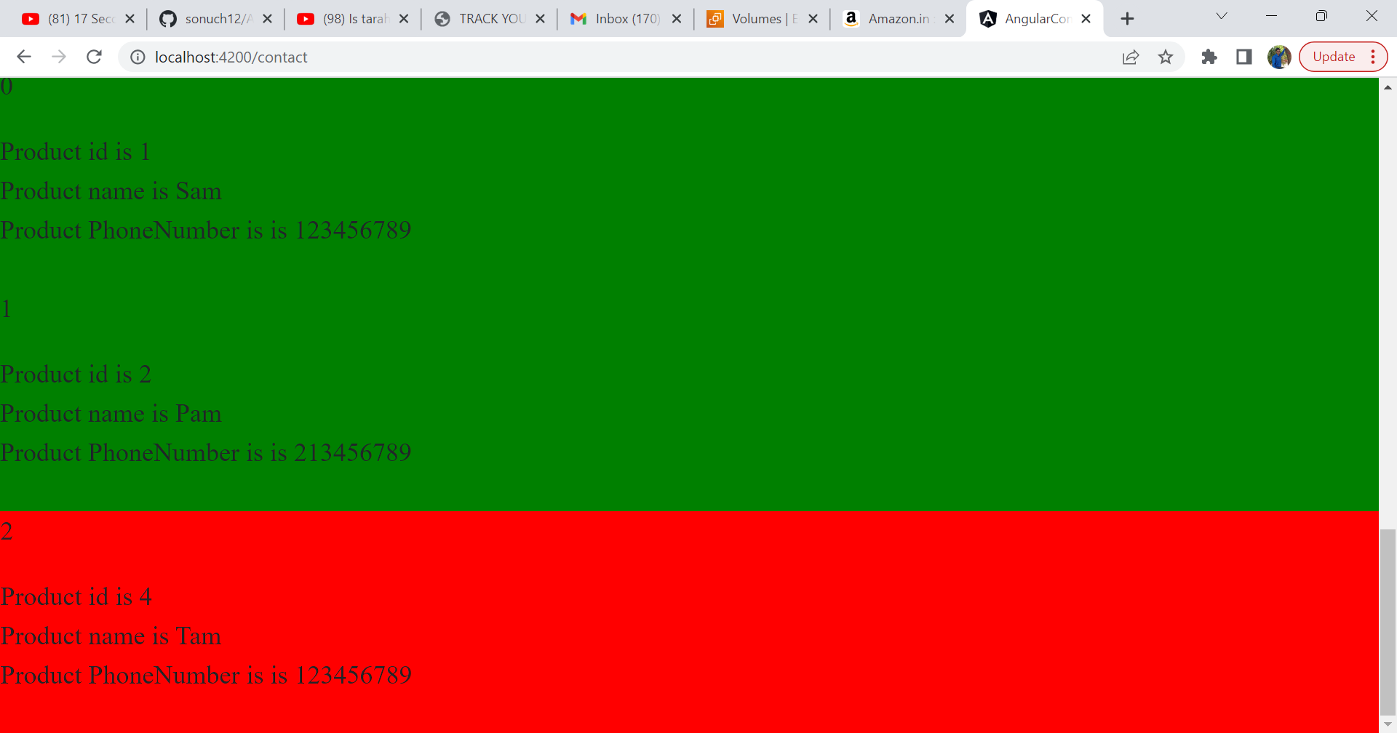

A program which contains every things

<h1>String interpolation ways<br />{{ slogan }}</h1>

<h2>Method call {{ firstMethod() }}</h2>

<h2>Calculation of 12+34+100 is {{ 12 + 34 + 100 }}</h2>

<h3>Property Binding and showing the image</h3>

<img [src]="source" alt="No image is available" height="300" width="300" />

<h3>Now Event binding</h3>

<div>

  <input type="text" (input)="changeEvent($event)" />

  <span>You searched for "{{ str }}"</span>

</div>

<h3>Now using ngModel method we can send the data in both the ways</h3>

<input type="text" [(ngModel)]="strValue" />

<span>You searched for {{ strValue }}</span>

<h2>Use of Directives first nfgor</h2>

<div \*ngFor="let item of [20, 30, 40]">

  <p>Value is {{ item }}</p>

</div>

<h3>Use of ngFor product</h3>

<div \*ngFor="let p of prod">

  <p [ngStyle]="{ color: 'Orange' }">Id is {{ p.id }}</p>

  <p>Name is {{ p.name }}</p>

  <span

    [ngStyle]="{ backgroundColor: p.con === 'available' ? 'Green' : 'Red' }"

  >

    Cont is {{ p.con }}

  </span>

</div>

import { Component } from '@angular/core';

@Component({

  selector: '.app-notification',

  templateUrl: './notification.component.html',

  styleUrls: ['./notification.component.css'],

})

export class NotificationComponent {

  slogan: string = 'Welcome to Angular Notification';

  firstMethod() {

    return 'String interpolation using Method call';

  }

  source: string = '/assets/s1.jpg';

  str: string = '';

  changeEvent(eventData: any) {

    this.str = (<HTMLInputElement>eventData.target).value;

  }

  strValue: string = '';

  prod = [

    { id: 1, name: 'Sam', con: 'available' },

    { id: 2, name: 'Pam', con: 'notavailable' },

    { id: 3, name: 'Tam', con: 'available' },

  ];

}